Go to https://arcounselingandwellness.com/
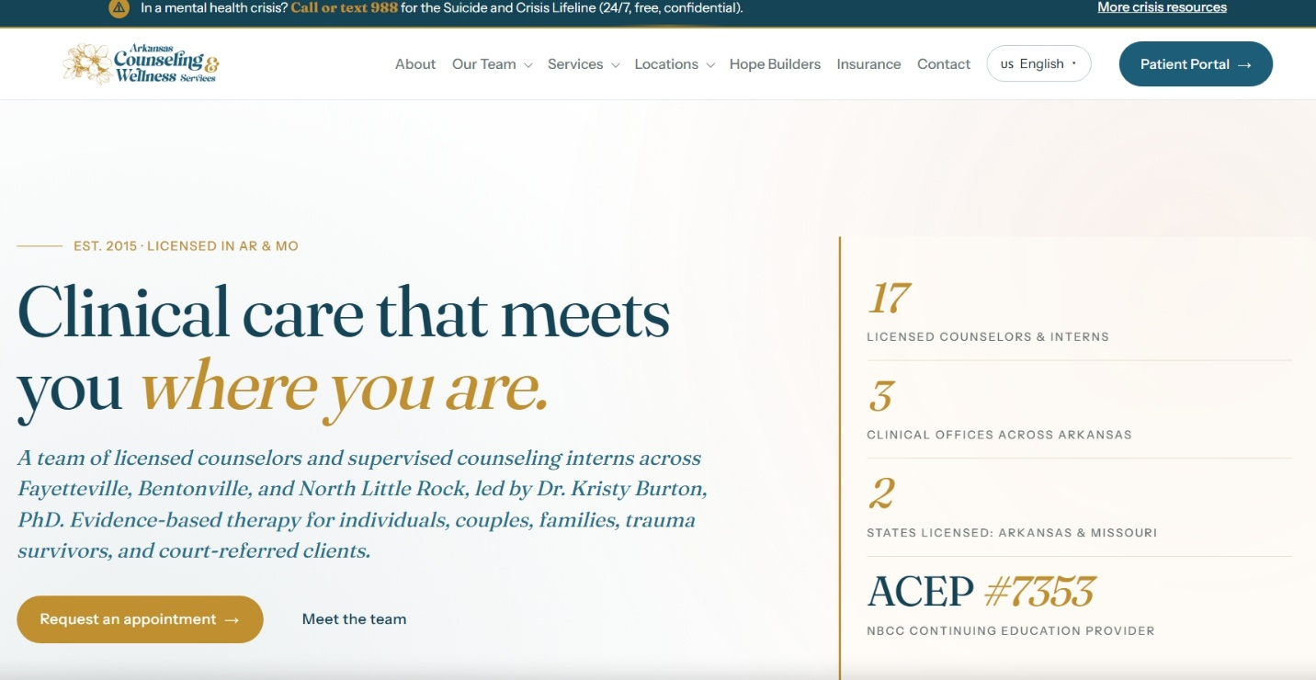

Click Services and then Click Domestic Violence (DVIP) under Court Approved.

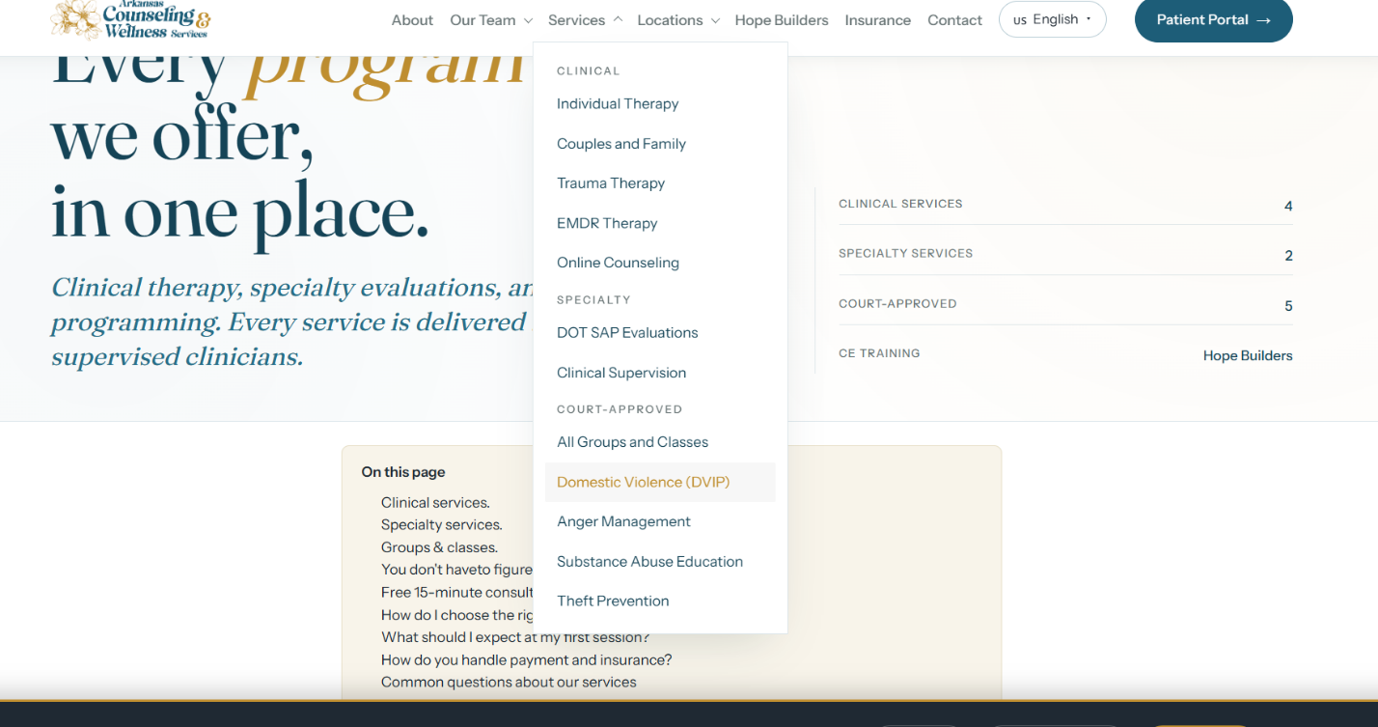
Scroll down until you see “How do I enroll?”. You can click Register for DVIP Program or call 501-205-4570 during admin hours (Monday through Thursday, 9AM to 4PM).
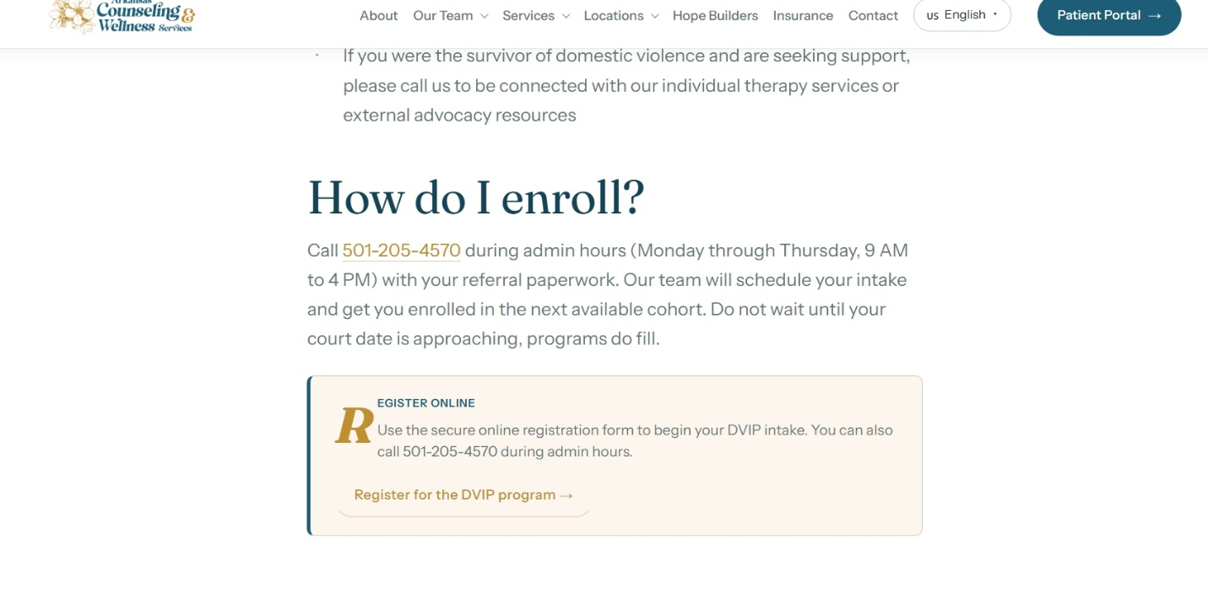Once you click Register for DVIP program fill out the form below.
